**Working on maven**

##### **Step 1: Install Maven**

# apt-get install maven

**Step 2 : clone the code from github to your machine**

# git clone https://github.com/mohamedji/https-github.com-g0t4-jenkins2-course-spring-boot.git

##### **Step 3: change directory**

cd https-github.com-g0t4-jenkins2-course-spring-boot/

##### **Step 4 : Goto Springboot sample of webstatic**

cd spring-boot-samples/spring-boot-sample-web-static/

##### **Step 5 : look at the directory structure**

tree .

#### 

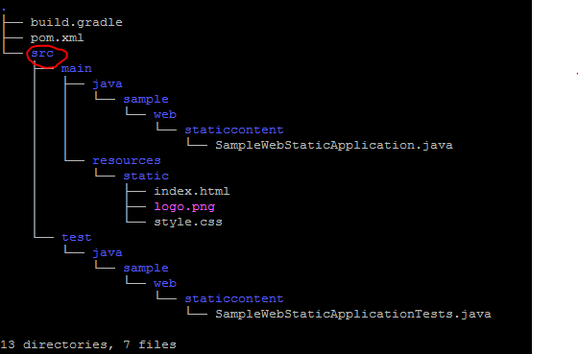

##### 

##### **Step 6 : Run Maven compile**

mvn compile

* Note compile - compile the source code of the project

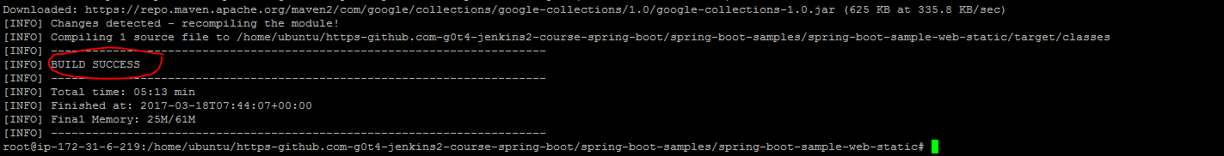

##### **Step 7 : note the directory structural changes**

tree .

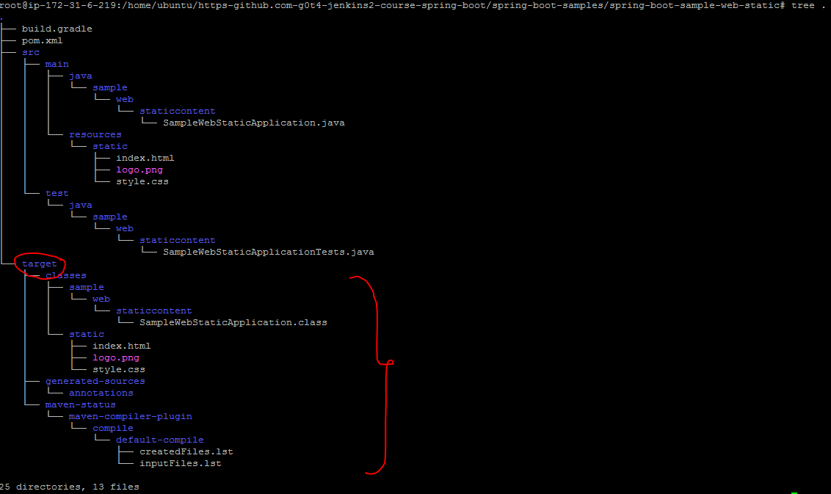

##### **Step 8 : Test**

mvn test

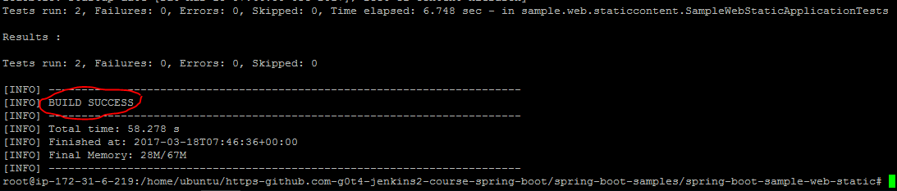

**Note :** test - test the compiled source code using a suitable unit testing framework. These tests should not require the code be packaged or deployed

**Step 8 : note the directory structural changes**

tree .

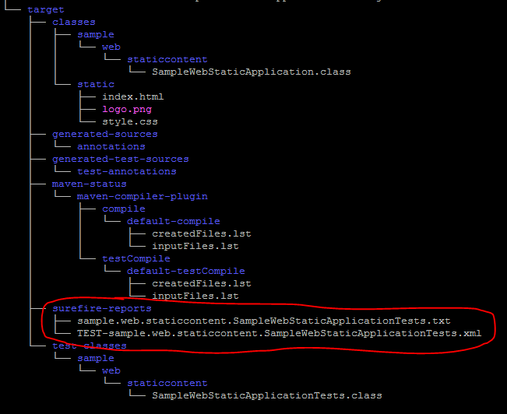

##### **Step 9 : Package**

mvn package

#### 

Note: package - take the compiled code and package it in its distributable format, such as a JAR.

#### 

ls -l target/

#### 

you will find the jar file named as spring-boot-sample-web-static-1.4.0.BUILD-SNAPSHOT.jar